**Project-4**

**Gundrala Bharath Kumar**

**Github::**

[**https://github.com/bharath4568/Class-Diagram-/blob/main/0nline_Grocery_store-2022-04-17_00-04.svg**](https://github.com/bharath4568/Class-Diagram-/blob/main/0nline_Grocery_store-2022-04-17_00-04.svg)

[**https://github.com/bharath4568/Sql-Script/blob/main/MySQL_demo_physical_data_model_create.sql**](https://github.com/bharath4568/Sql-Script/blob/main/MySQL_demo_physical_data_model_create.sql)

[**https://github.com/bharath4568/Employee.csv/blob/main/Employee.csv**](https://github.com/bharath4568/Employee.csv/blob/main/Employee.csv)

[**https://github.com/bharath4568/Sales.csv/blob/main/Sales.csv**](https://github.com/bharath4568/Sales.csv/blob/main/Sales.csv)

[**https://github.com/bharath4568/Product.csv/blob/main/product.csv**](https://github.com/bharath4568/Product.csv/blob/main/product.csv)

[**https://github.com/bharath4568/Customer.csv/blob/main/Customer.csv**](https://github.com/bharath4568/Customer.csv/blob/main/Customer.csv)

[**https://github.com/bharath4568/Payment.csv/blob/main/Payment.csv**](https://github.com/bharath4568/Payment.csv/blob/main/Payment.csv)

[**https://github.com/bharath4568/Grocery.csv/blob/main/Online_Grocery_Store.csv**](https://github.com/bharath4568/Grocery.csv/blob/main/Online_Grocery_Store.csv)

**ER Diagram :**

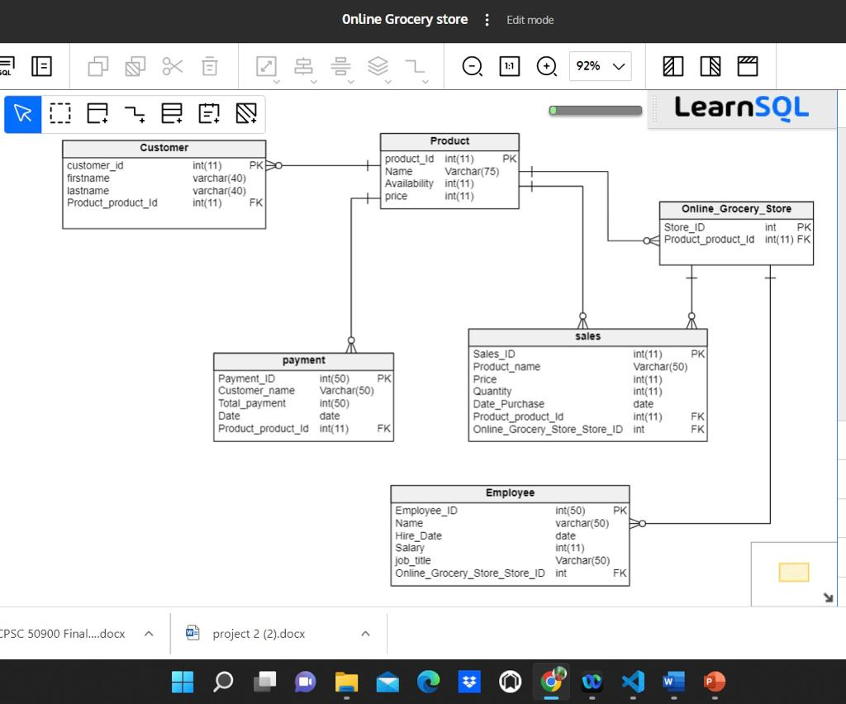

**Two insert statements**:

Insert into employee values(201, 'bunny', '2020-01-10', 30000.00, 'Accountant',101);

Insert into employee values(203, 'karthik', '2019-10-08', 50000.00, 'Manager',103);

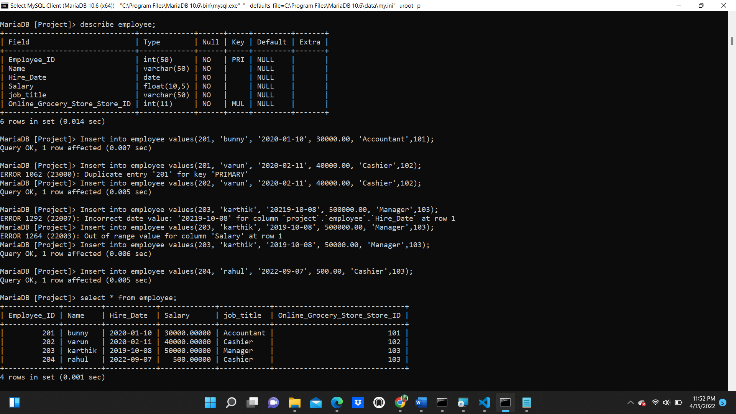

**Update Statements:**

update sales Quantity=200 where Sales_ID=1600;

update employee set Salary=2500.00 where Name='rahul';

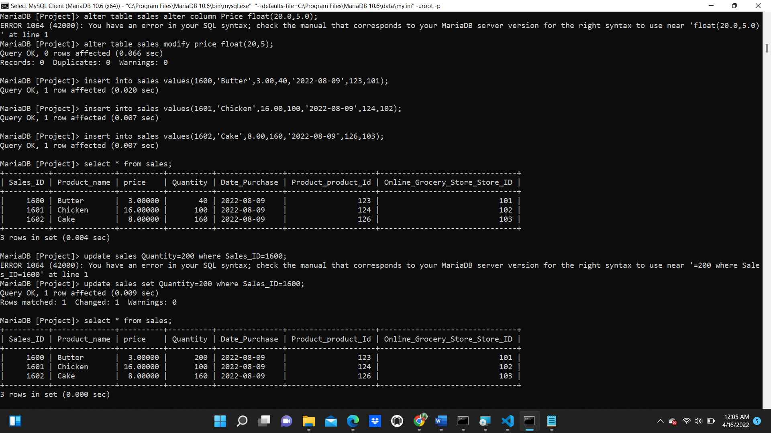

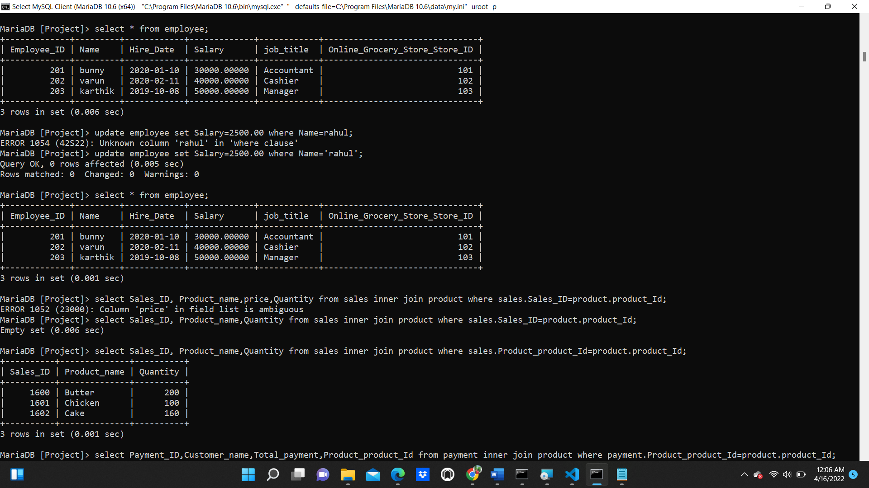

**Delete stmt:**

delete from product where product_Id=125

delete from payment where Payment_ID=3004;

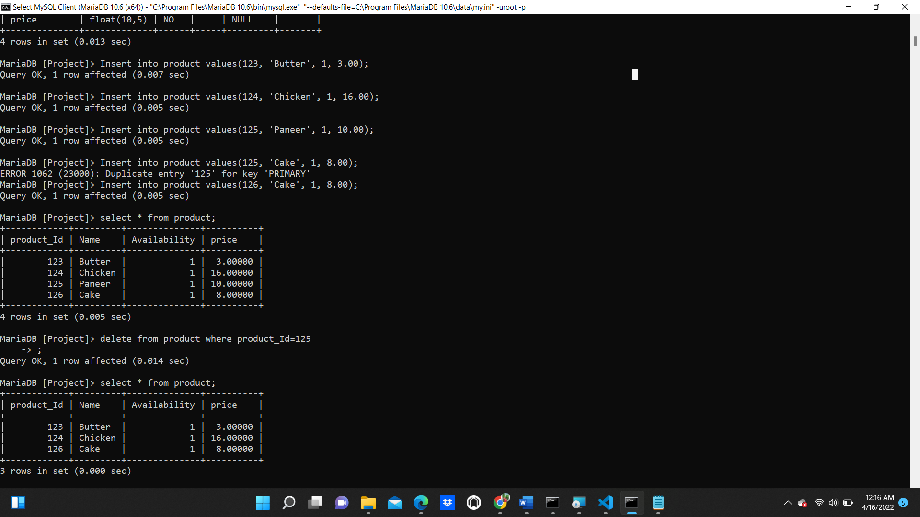

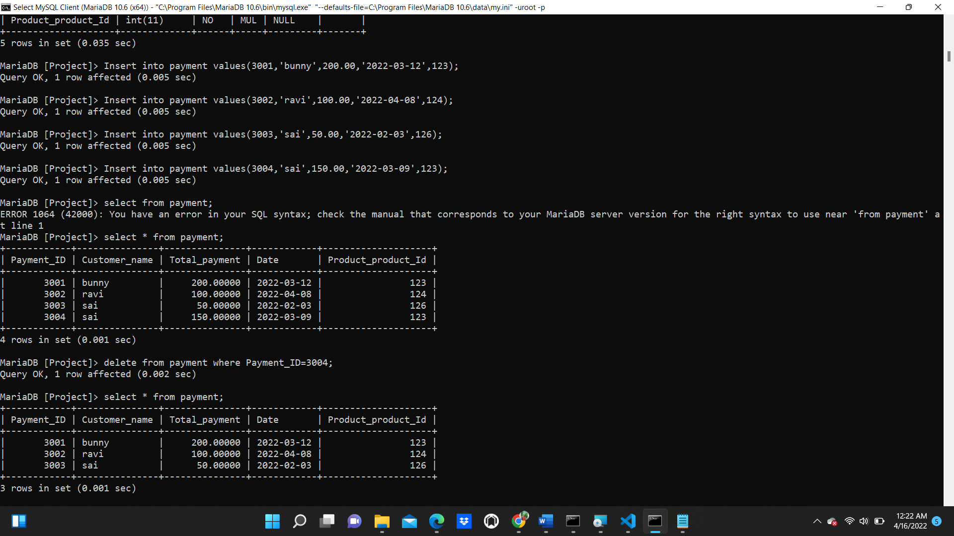

**Simple Select Stmt :**

select * from employee;



**Join and Multi table Query:**

select Sales_ID, Product_name,Quantity from sales inner join product where sales.Product_product_Id=product.product_Id;

select Sales_ID, Product_name,Quantity from sales inner join product where sales.Product_product_Id=product.product_Id;

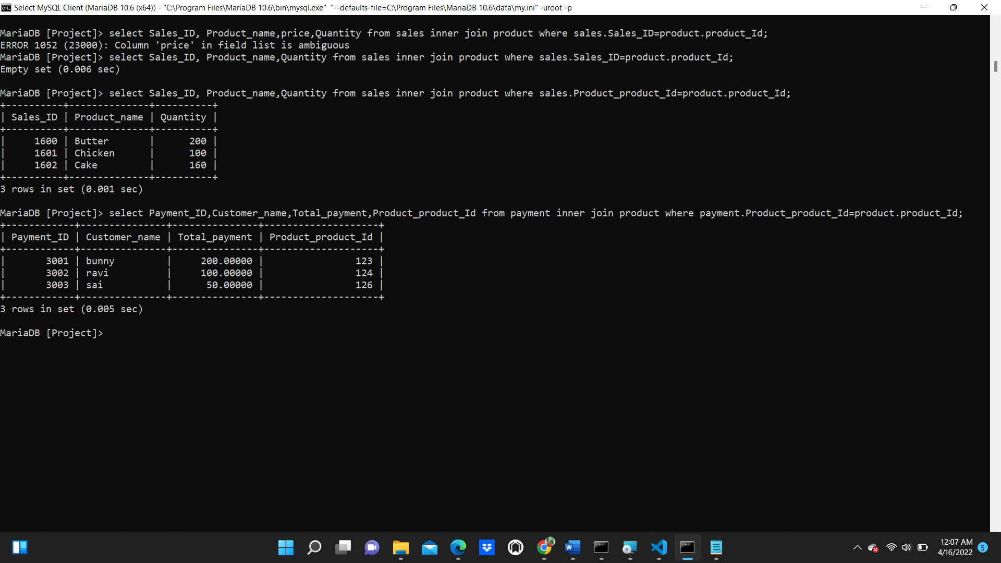

**Summary Statements:**

select * from customer;

select * from employee;

select * from payment;



